## 

Setting up Git

Setting up Git SSH Keys

Create a Git repository & Clone

Pushing Changes

Trying out Github Actions

Creating secrets in Github Actions

Mini-Assignment (Terraform)

Simple Ansible tasks

Setting up SSH keys across servers

What is ansible?

What is an ansible task?

What is an ansible playbook?

What is an ansible inventory file?

## 

## Setting up Git

Follow the step by step guide listed here - <https://kinsta.com/knowledgebase/install-git/> - which works for both Windows and Mac OS.

Once successfully installed, verify by running “git version” on your terminal/ powershell. Note: you do not need to go into bash mode for Windows user, you can continue from powershell.

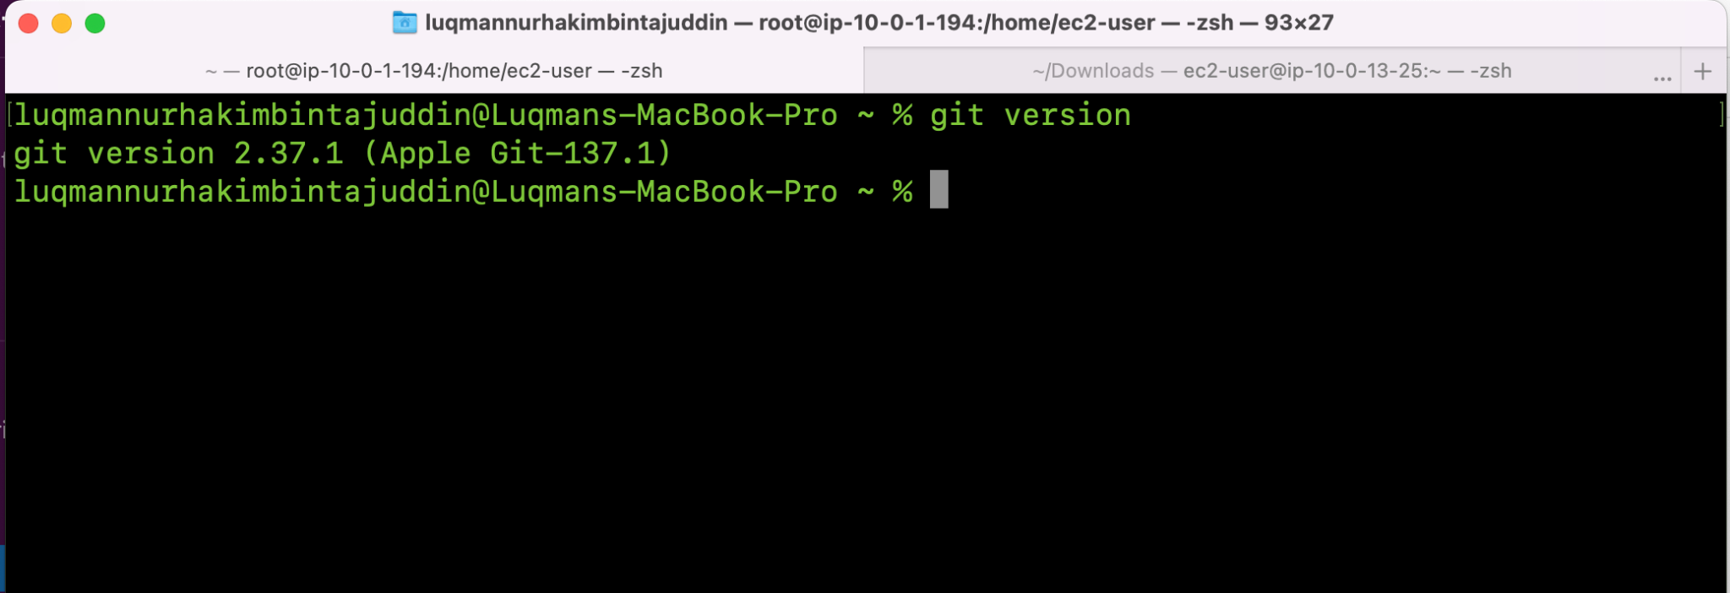

## Setting up Git SSH Keys

Our preferred authentication mechanism would be to use SSH connection. You will notice later that Git allows you to authenticate through 3 modes - HTTPS, SSH and Github Client.

Throughout our course, we will be using SSH authentication, where we will need to copy our public key and paste it into the Git console.

You can refer to these two documents as well:

1. <https://docs.github.com/en/authentication/connecting-to-github-with-ssh/generating-a-new-ssh-key-and-adding-it-to-the-ssh-agent#adding-your-ssh-key-to-the-ssh-agent>
2. <https://docs.github.com/en/authentication/connecting-to-github-with-ssh/adding-a-new-ssh-key-to-your-github-account>

First, run the below command to generate a new SSH key on your local computer:

ssh-keygen -t ed25519 -C "your_email@example.com"

Use the default values by clicking “Enter” until the key has been generated successfully.

Then, copy the content of your public key. You can find the public key in the directory (~/.ssh/id_ed25519.pub).

Go to your internet browser (Profile (top right) > Settings > SSH & GPG Keys > New SSH Key > Add SSH Key)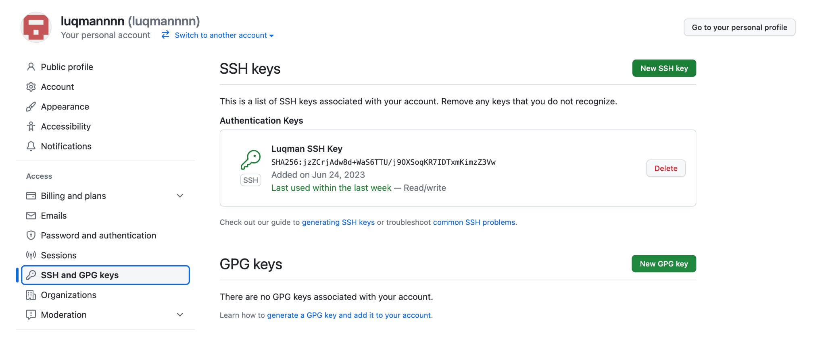

## Create a Git repository & Clone

From the Github console on your browser, create a new repository. Let’s call it “mysimpleminiproject”.

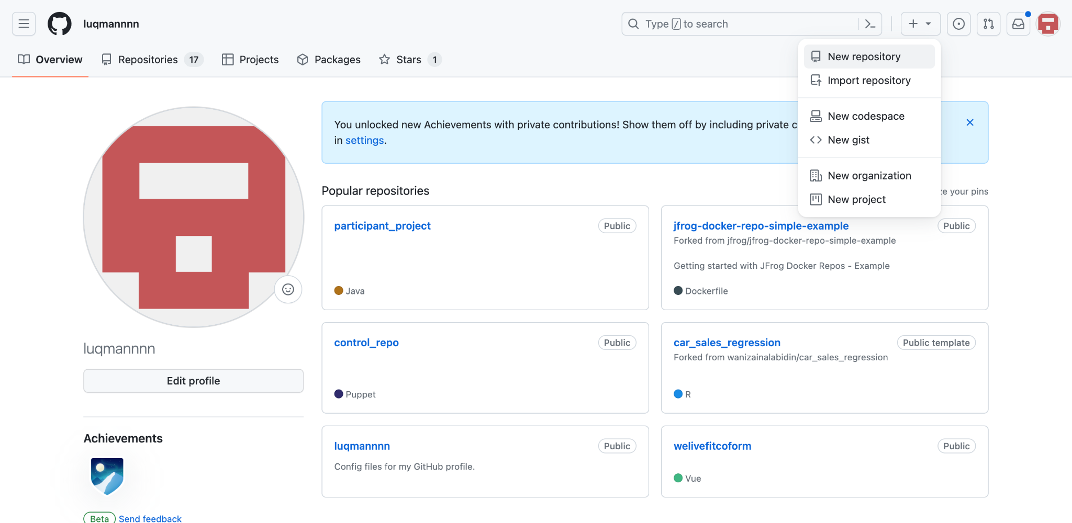

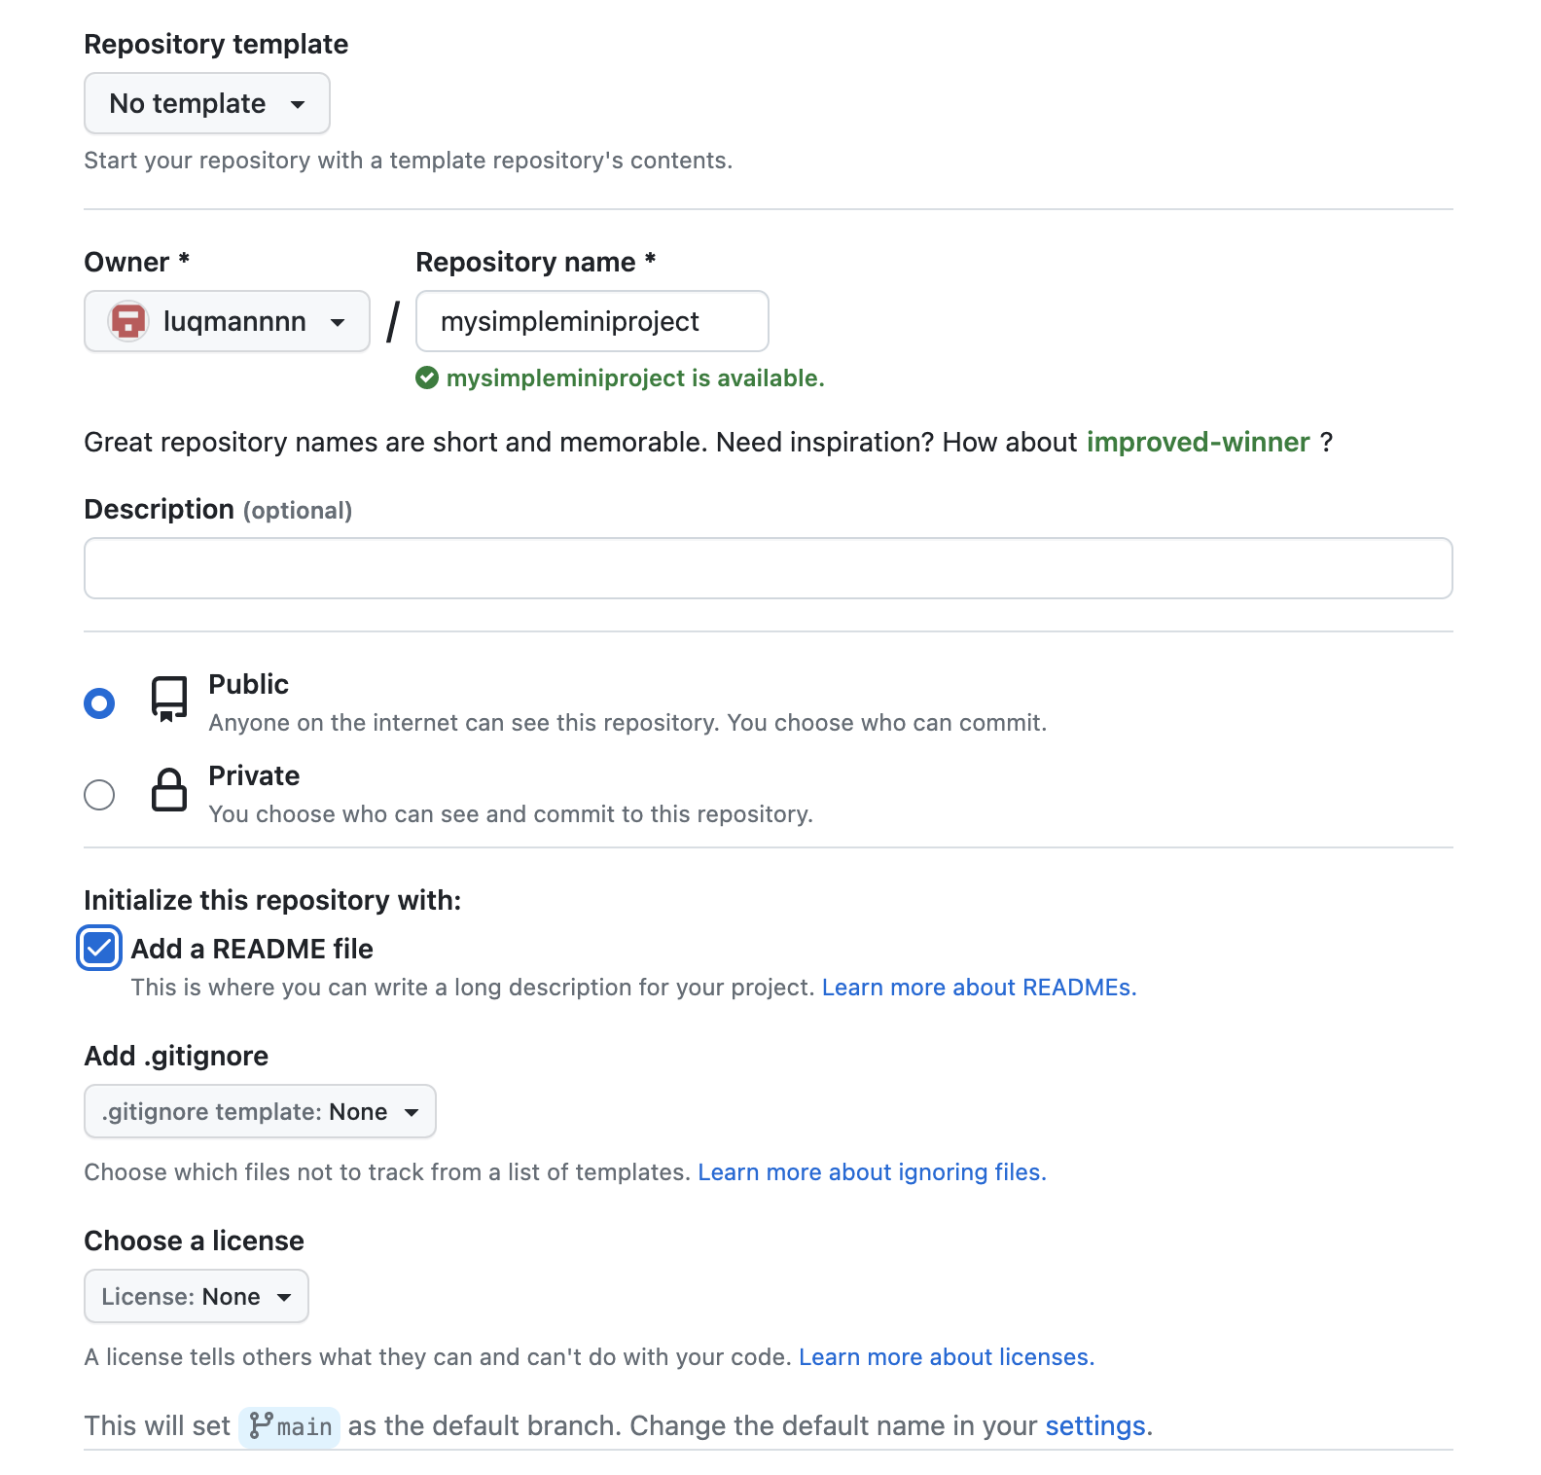

Once done, on your terminal/ powershell, change to a directory of your choice e.g. Desktop or Documents folder.

Back on your browser, copy the SSH URL of your newly created repository:

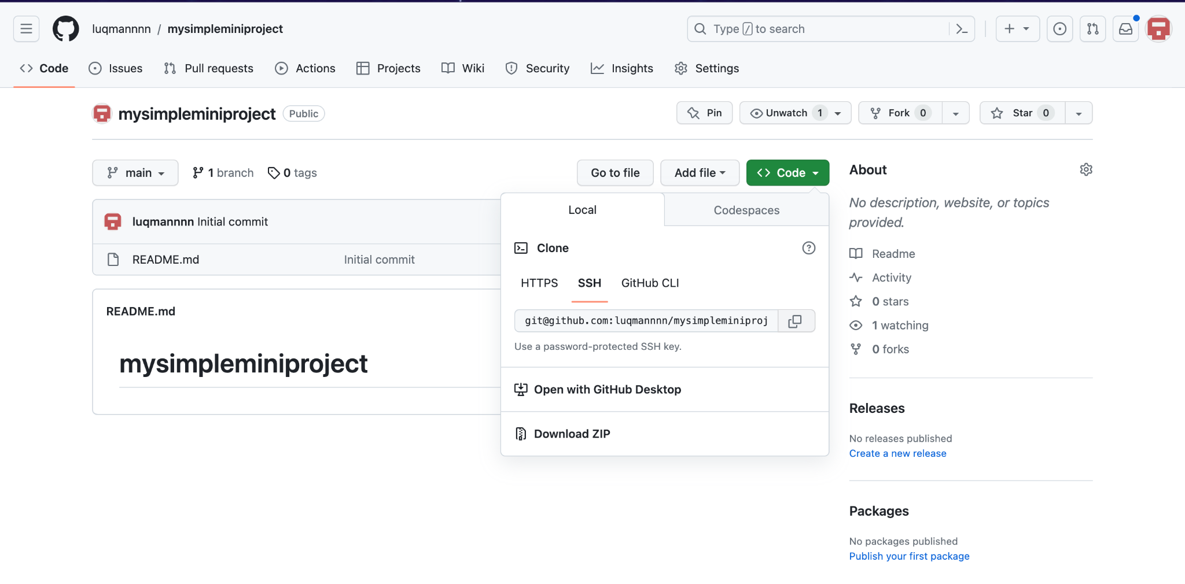

Back on your terminal/ powershell, run the command:  
git clone <SSH URL> e.g.

git clone [git@github.com](mailto:git@github.com):luqmannn/mysimpleminiproject.git

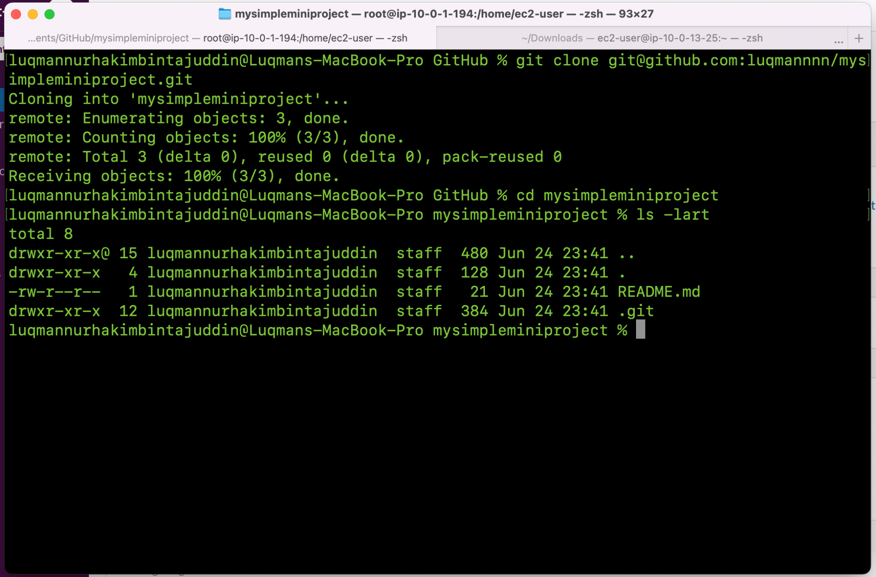

If successful, you should see a new folder created with some files in it like a .git folder.

*Note: if you are having timeout issue, do the following:*

sudo vi ~/.ssh/config

And add the following

Host github.com

Hostname ssh.github.com

Port 443

Hit ESC and type “:wq!” to save changes. Try running “git clone” again.

## Pushing Changes

Git allows you to make changes to existing files from your local machines. We will normally create branches in Git, which allows you to create changes in your own environment before you merge the changes back to the main branch, where other developers/ engineers share code.

For this assignment, we will utilize the main branch directly. In modules 3.1 and 3.2, our instructors will share more on how to create branches and pull requests.

Edit your existing README.md file and save your changes.

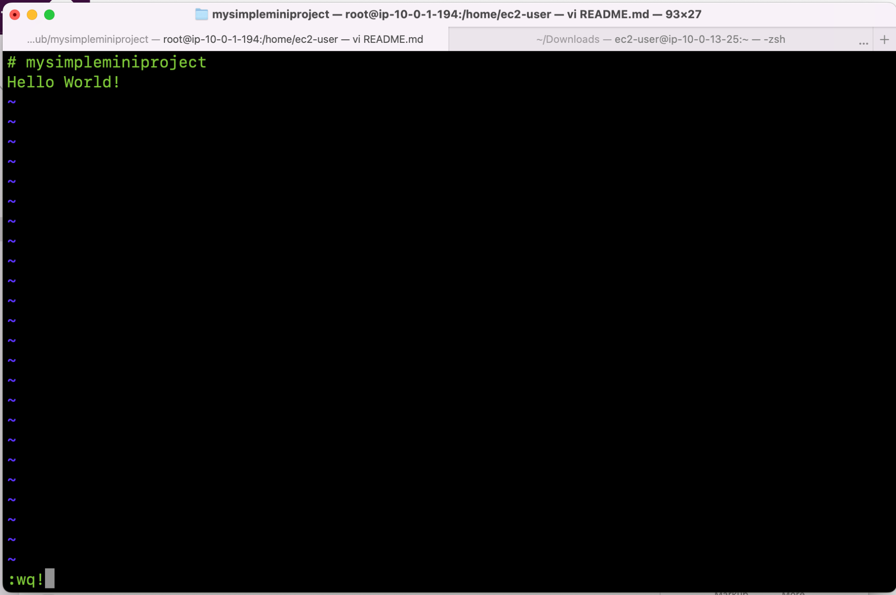

Once your changes are made, you can run “git status” to view the changes tracked by git.

When you’re ready to commit your changes, run “**git add .”** followed by “**git commit -m “<commit message>”** “.

Finally, run “**git push**” to push your changes to Github.

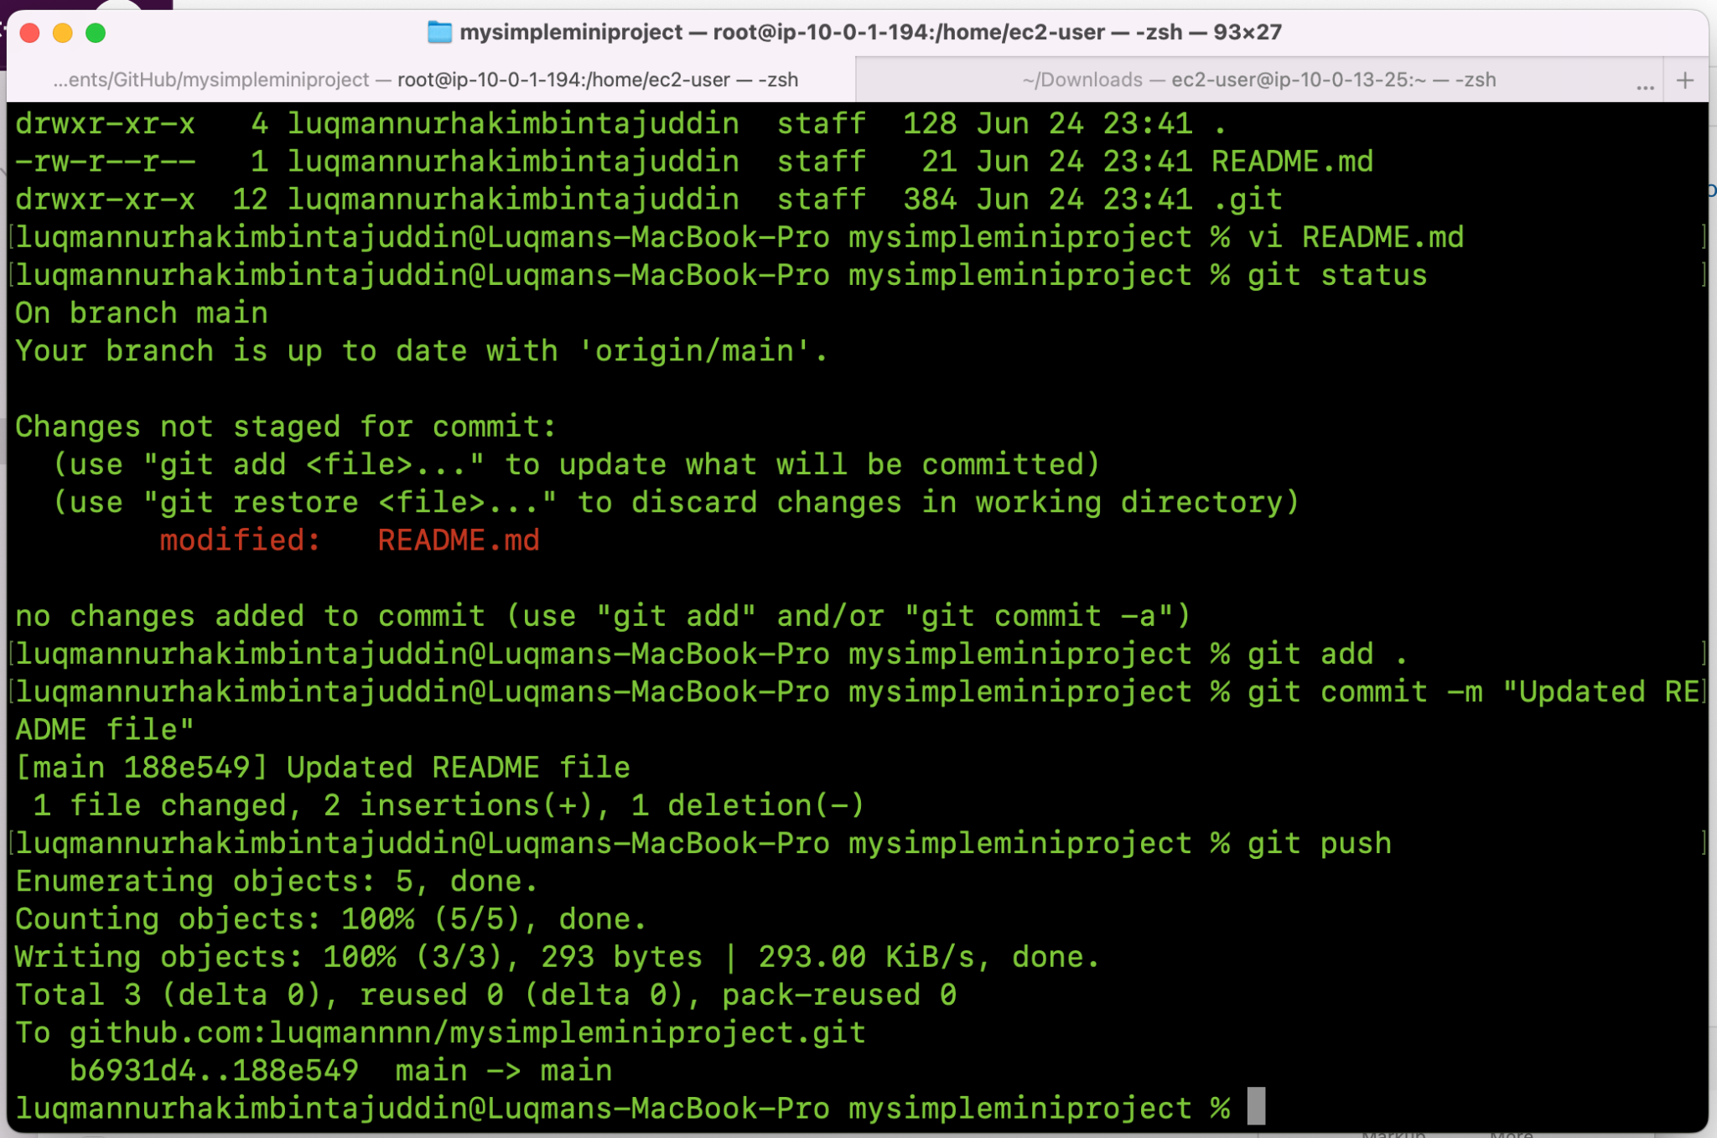

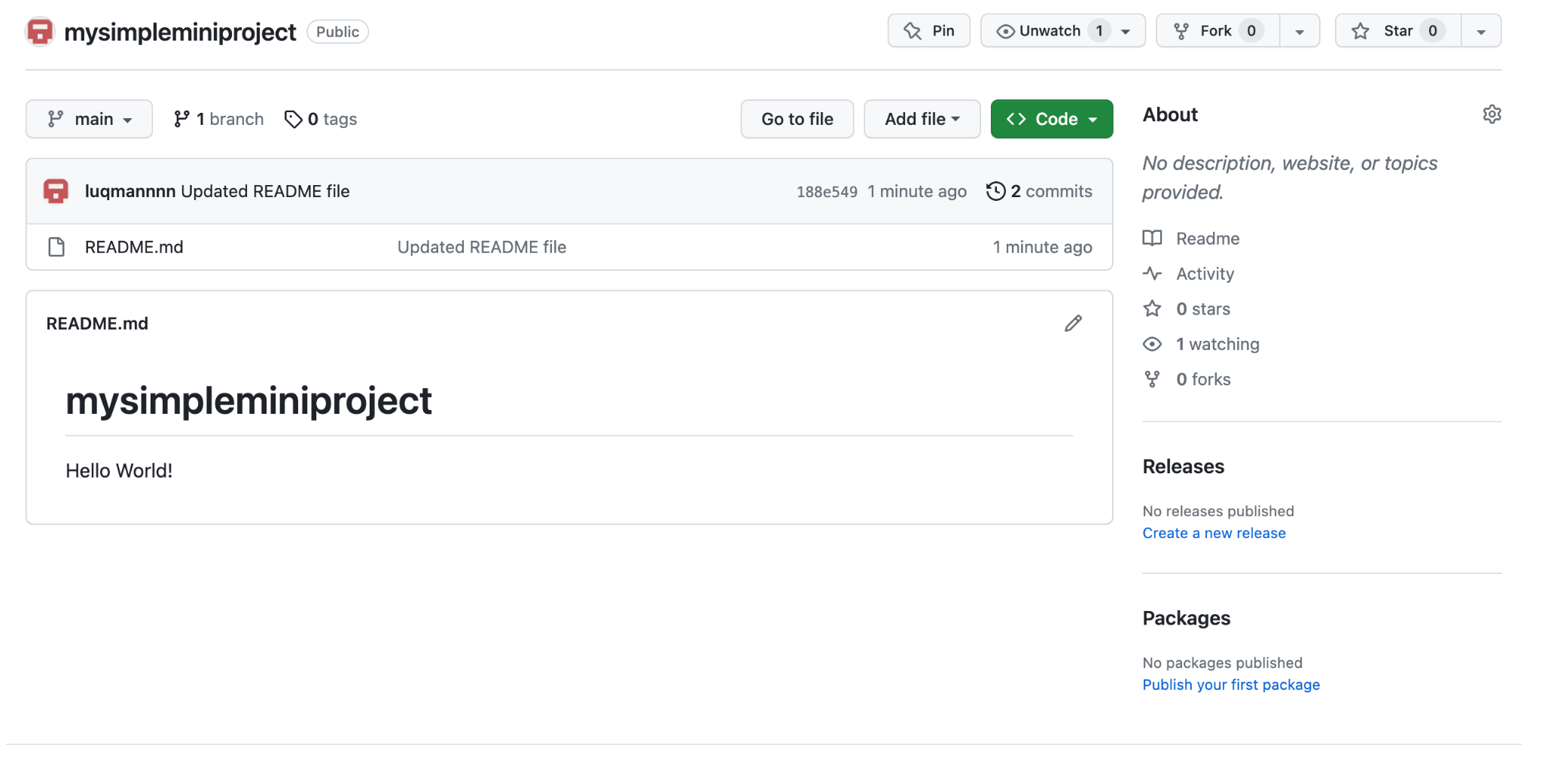

## 

## Trying out Github Actions

Open your Github repository folder in Visual Studio Code.

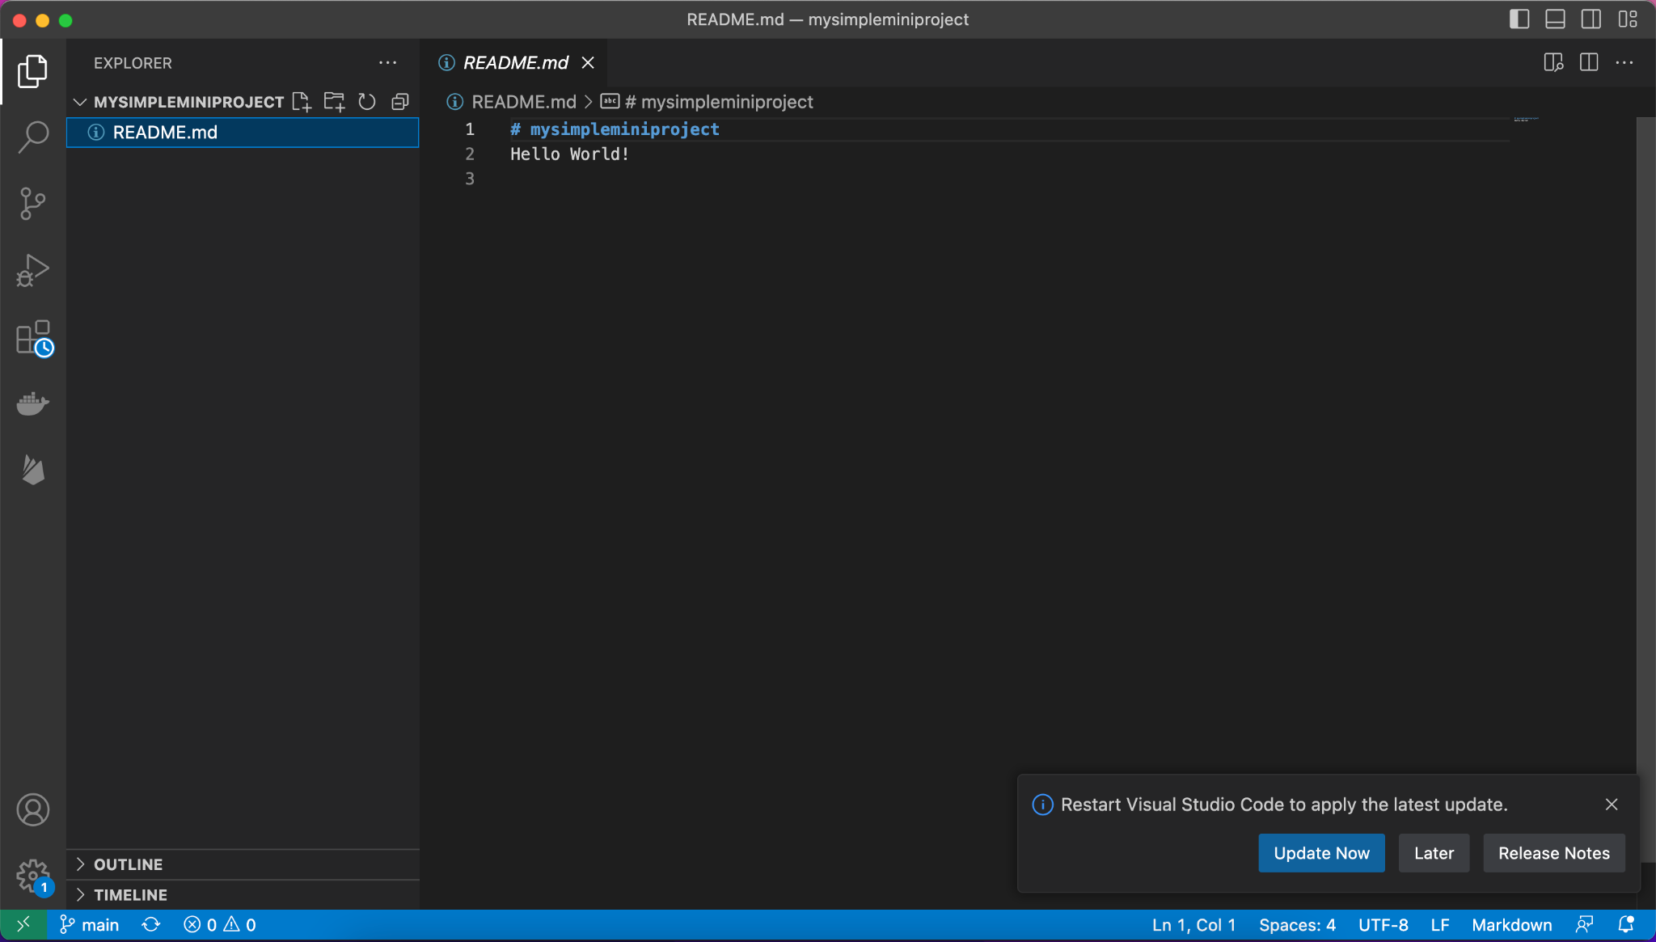

Create a new folder called “.github/workflows” in Visual Studio Code.

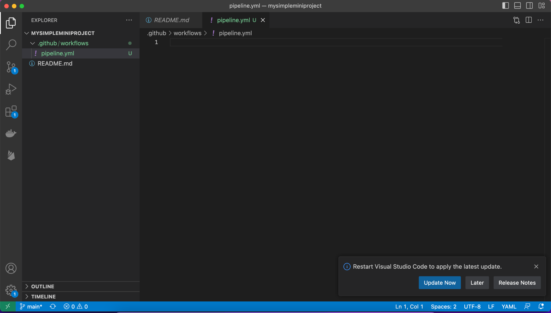

Copy and paste the content below in a file called “pipeline.yml” which is under .github/workflows folder:

name: Terraform Deployment

on:

push:

branches:

- main

jobs:

terraform:

runs-on: ubuntu-latest

steps:

- name: Checkout repository

uses: actions/checkout@v2

- name: Set up Terraform

uses: hashicorp/setup-terraform@v1

- name: Configure AWS credentials

uses: aws-actions/configure-aws-credentials@v1

with:

aws-access-key-id: ${{ secrets.AWS_ACCESS_KEY_ID }}

aws-secret-access-key: ${{ secrets.AWS_SECRET_ACCESS_KEY }}

aws-region: <input your region> # e.g. eu-west-2

- name: Initialize Terraform

run: terraform init

- name: Terraform Plan

run: terraform plan

- name: Terraform Apply

run: terraform apply --auto-approve

## Creating secrets in Github Actions

Go to Settings in your Github repository:

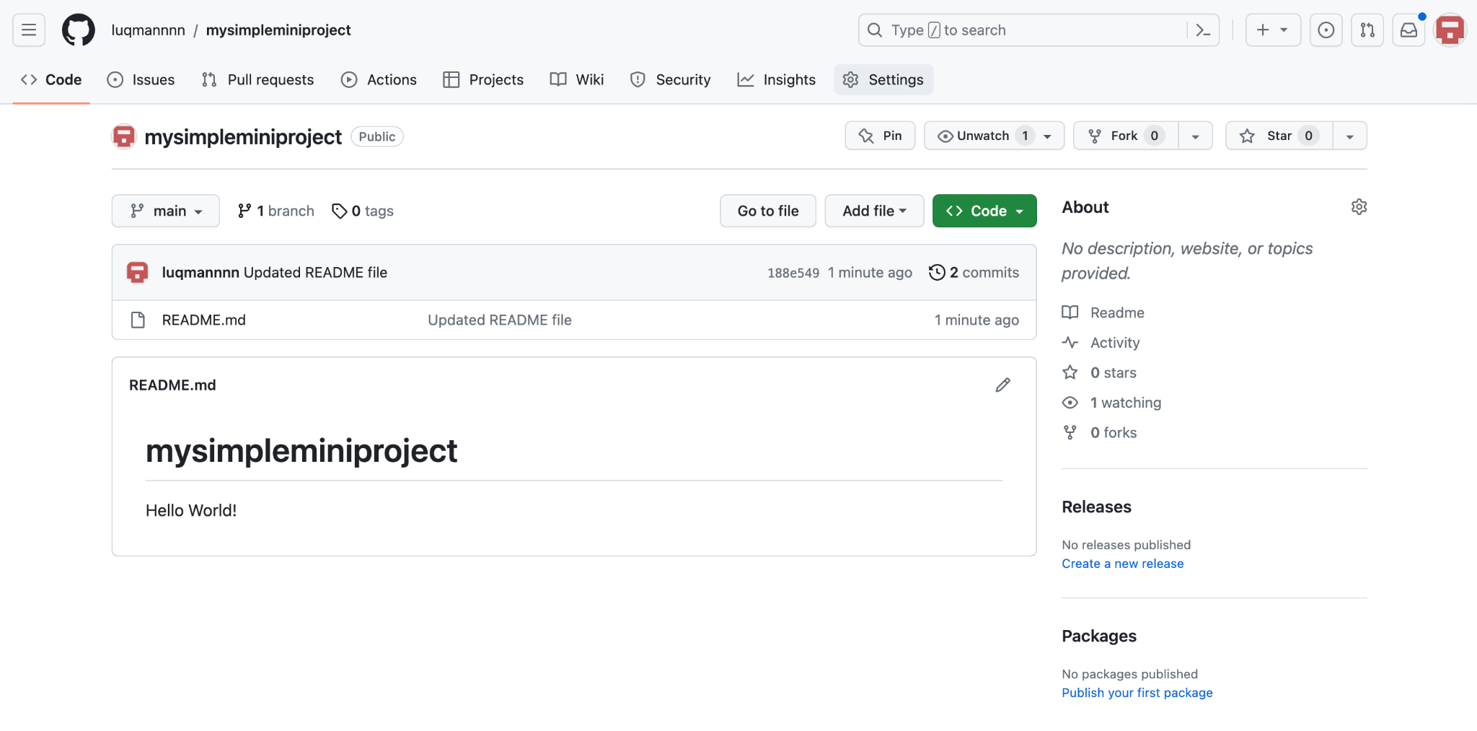

Click “Actions” under “Secrets and variables”

## 

Here, you can add 2 secrets - AWS_ACCESS_KEY_ID and AWS_SECRET_ACCESS_KEY. You can get these values from the AWS console under IAM.

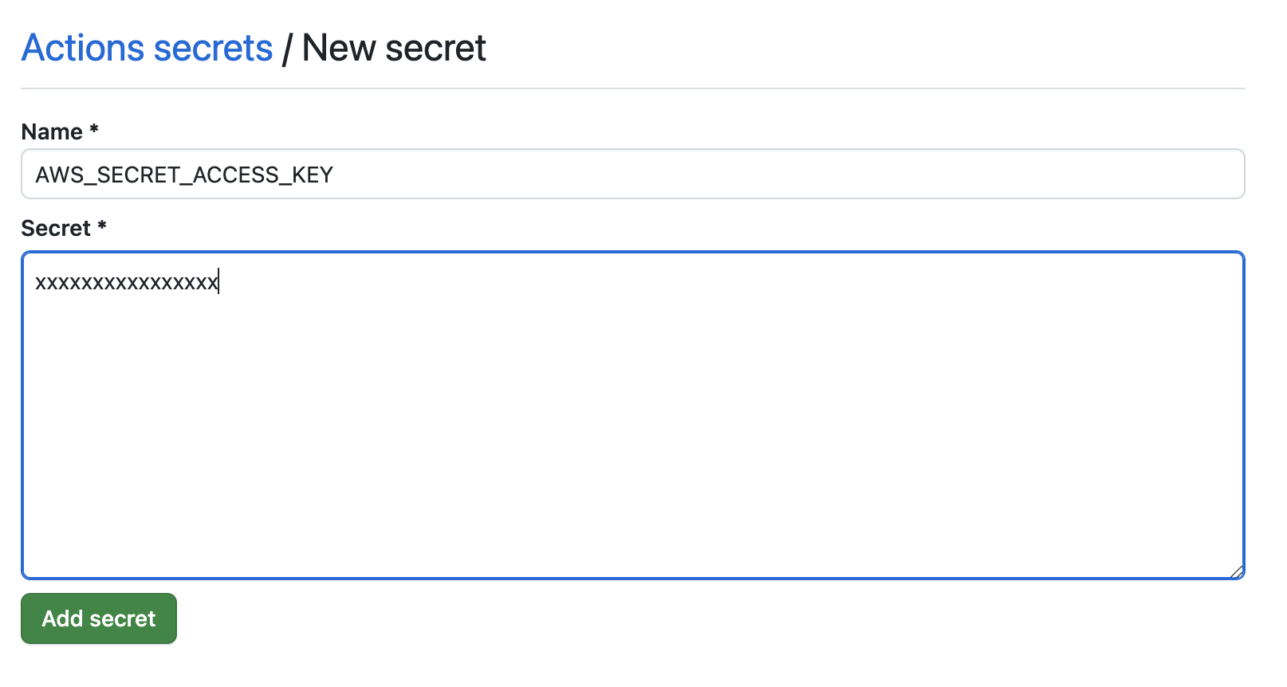

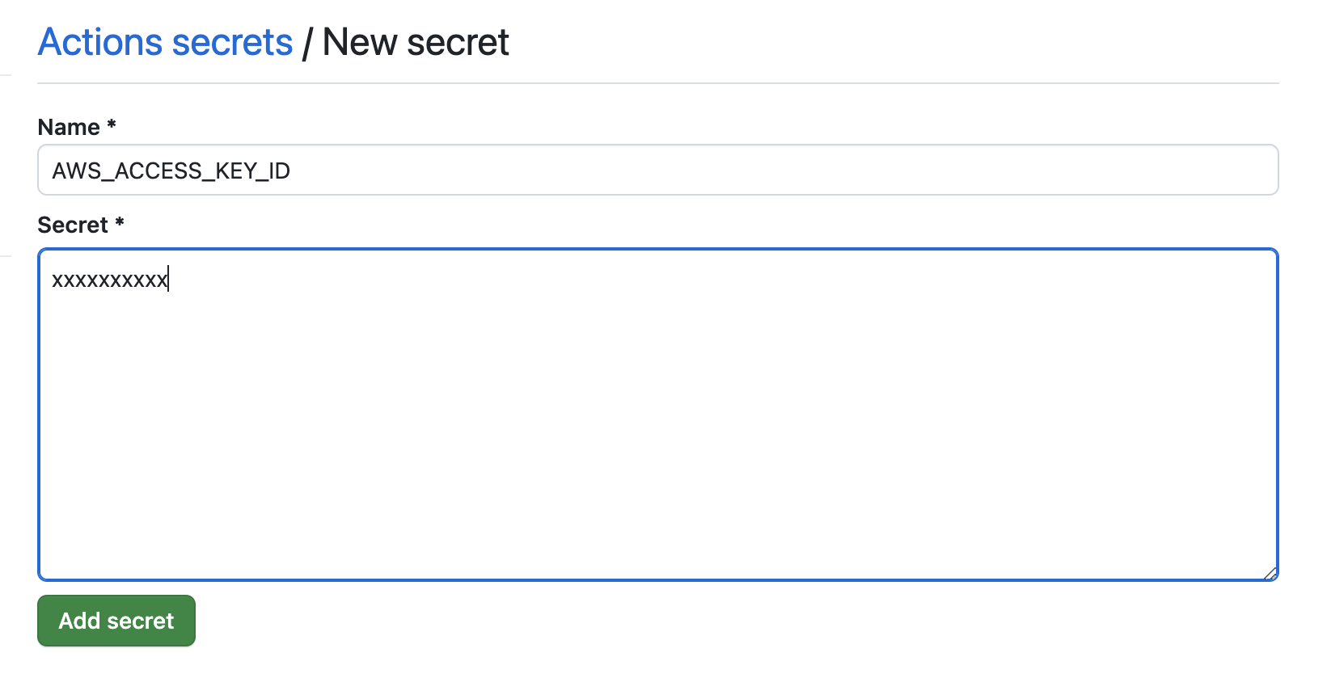

Recall: How do you create the Access keys?

Hint: AWS Console > IAM > User

## Mini-Assignment (Terraform)

Your task will be to create the following using terraform (name the file main.tf):

2 EC2 VMs called Webserver-1 and Webserver-2. These web servers should have:

* Instance Type - t2.micro,
* AMI - any Amazon Linux AMI in your region,
* Keypair - your own keypair for SSH login (you should create from the console in advance or try using <https://registry.terraform.io/providers/hashicorp/tls/3.0.0/docs/resources/private_key> in your terraform code),
* associate_public_ip_address - set to “true”,
* subnet_id - use an existing public subnet in your specified region belonging to an existing VPC. Otherwise, feel free to create a new VPC and public subnet.
* vpc_security_group_ids - use an existing security group with SSH, ICMP and HTTPS allowed (0.0.0.0/0 is fine for this activity)

Feel free to read up more on the documentation for help on how to set the above variables for an EC2 server: <https://registry.terraform.io/providers/hashicorp/aws/latest/docs/resources/instance>

Create 1 more EC2 VM with the same above specifications called Ansibleserver. Ansibleserver, however, should have an additional user_data block which installs Ansible. The script is as such:

#!/bin/bash

sudo yum update -y

sudo yum install pip -y

sudo python3 -m pip install --user ansible

The main.tf file can be in the root directory of your git folder e.g.:

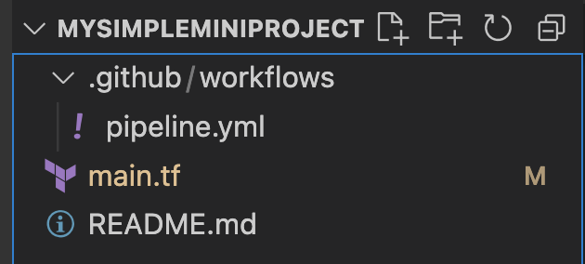

Once you’re ready, do a git add of all your new and existing changed files, followed by git commit -m <message> and a git push.

With your .github/workflows/pipeline.yml and main.tf file (you do not need a provider.tf file for now), you should see a Github Actions Pipeline being triggered.

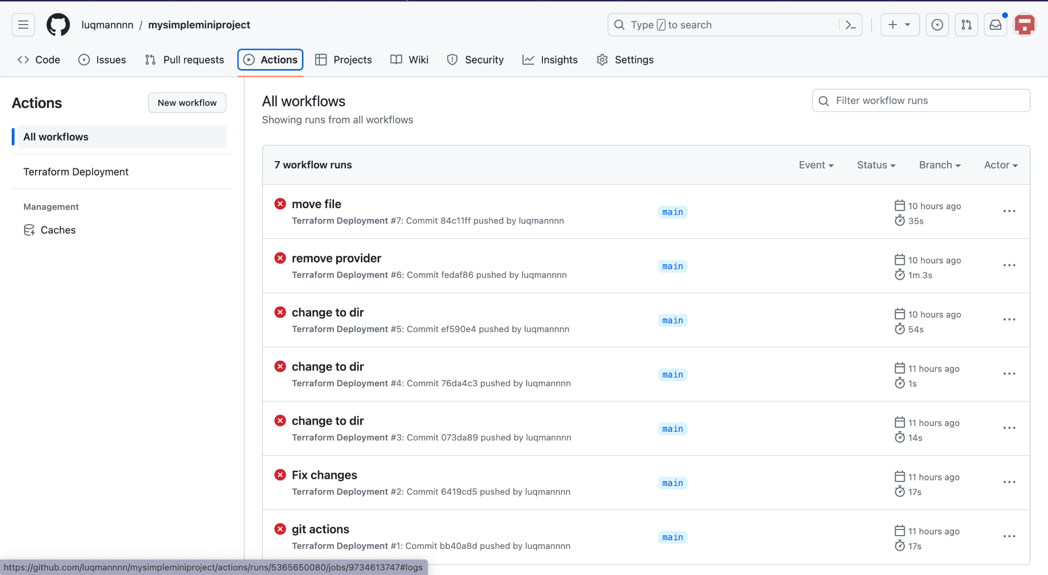

Note: You might see errors (like me above 😂) and you can drill down into the issues by clicking into the workflow run. Try troubleshooting the errors by making changes on your local machine and pushing them to Github to trigger a new workflow.

Once it is successful, you will see a green tick with more logs that showed the resources that were created from your terraform apply step.

Below is an example of a Github Actions screenshot:

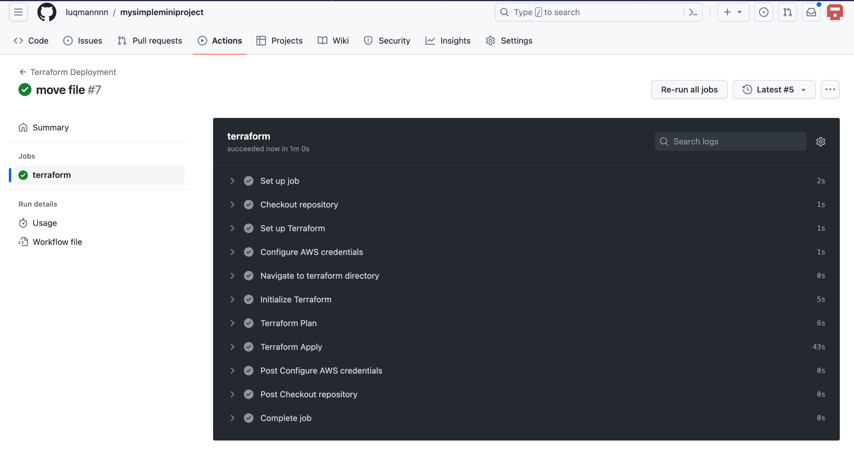

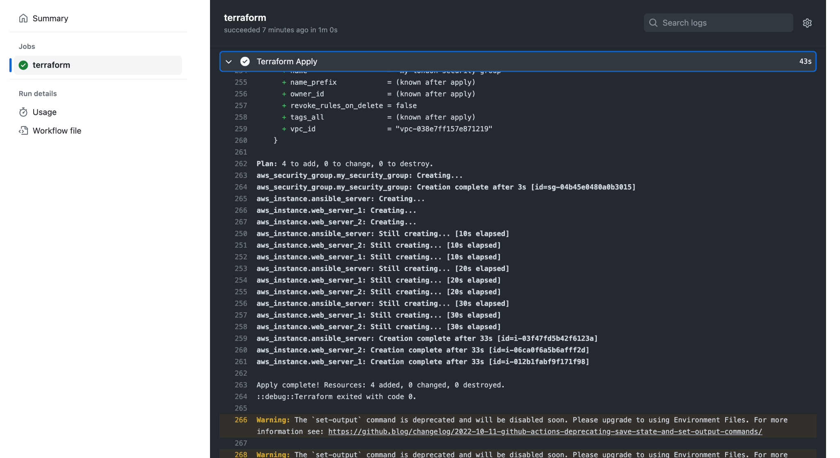

Head over to the AWS console to verify that all your EC2 were created successfully:

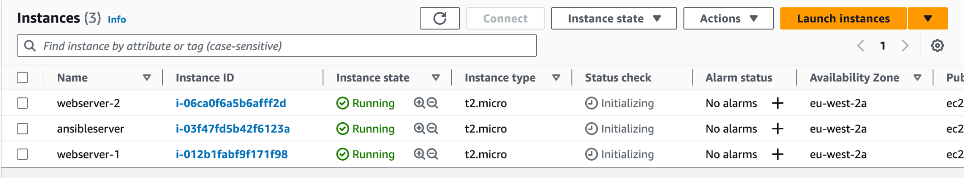

Next, ensure that you can connect to the VM using the key pair associated in the terraform code:

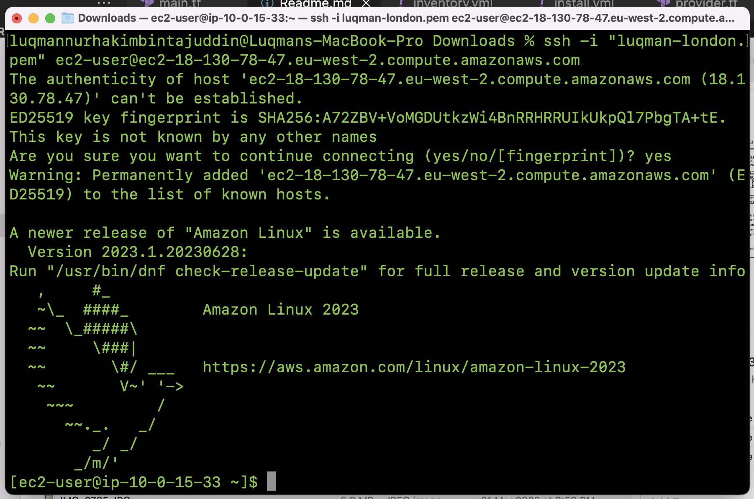

On the ansibleserver, run the below command to ensure that ansible has been successfully installed:

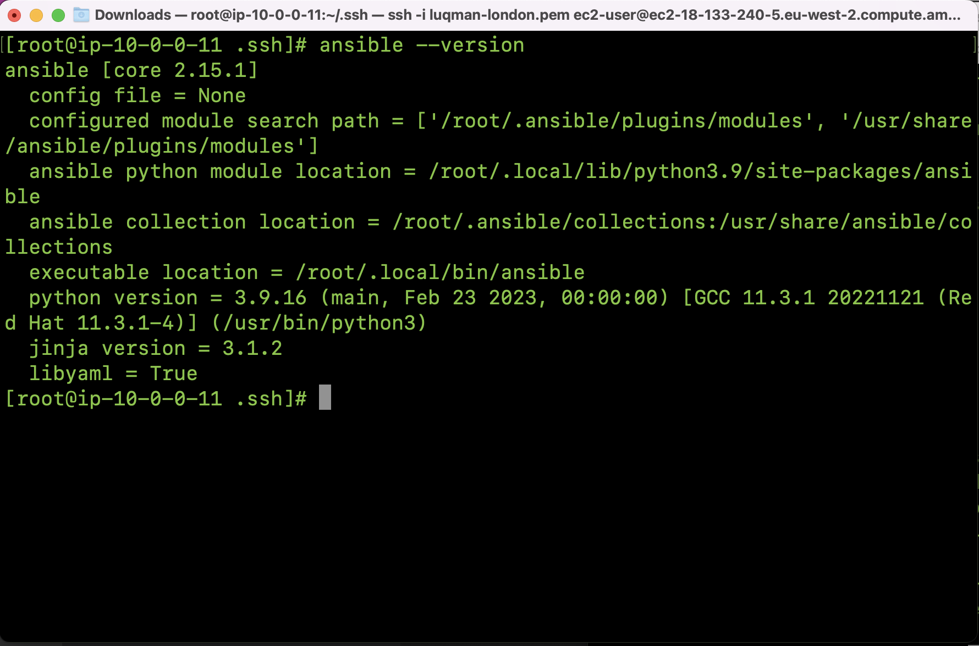

Happy trying before the Ansible activity!

## Ansible Set-up

### Setting up SSH keys across servers

In order to allow communication between servers, we will need to set up SSH keys and copy the public key to the target server.

On your ansibleserver, run the following commands:

| ssh-keygen -t rsa |
| --- |

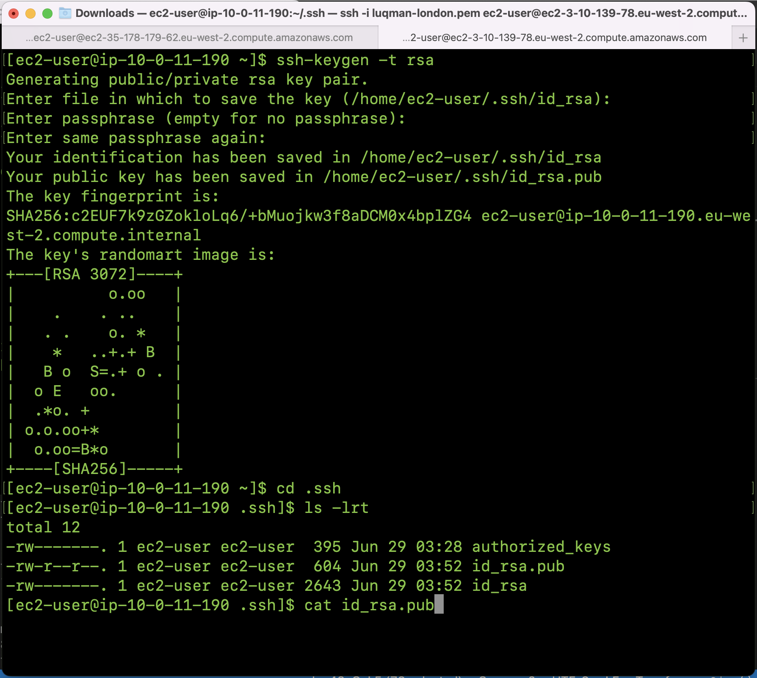

Copy the contents of id_rsa.pub.

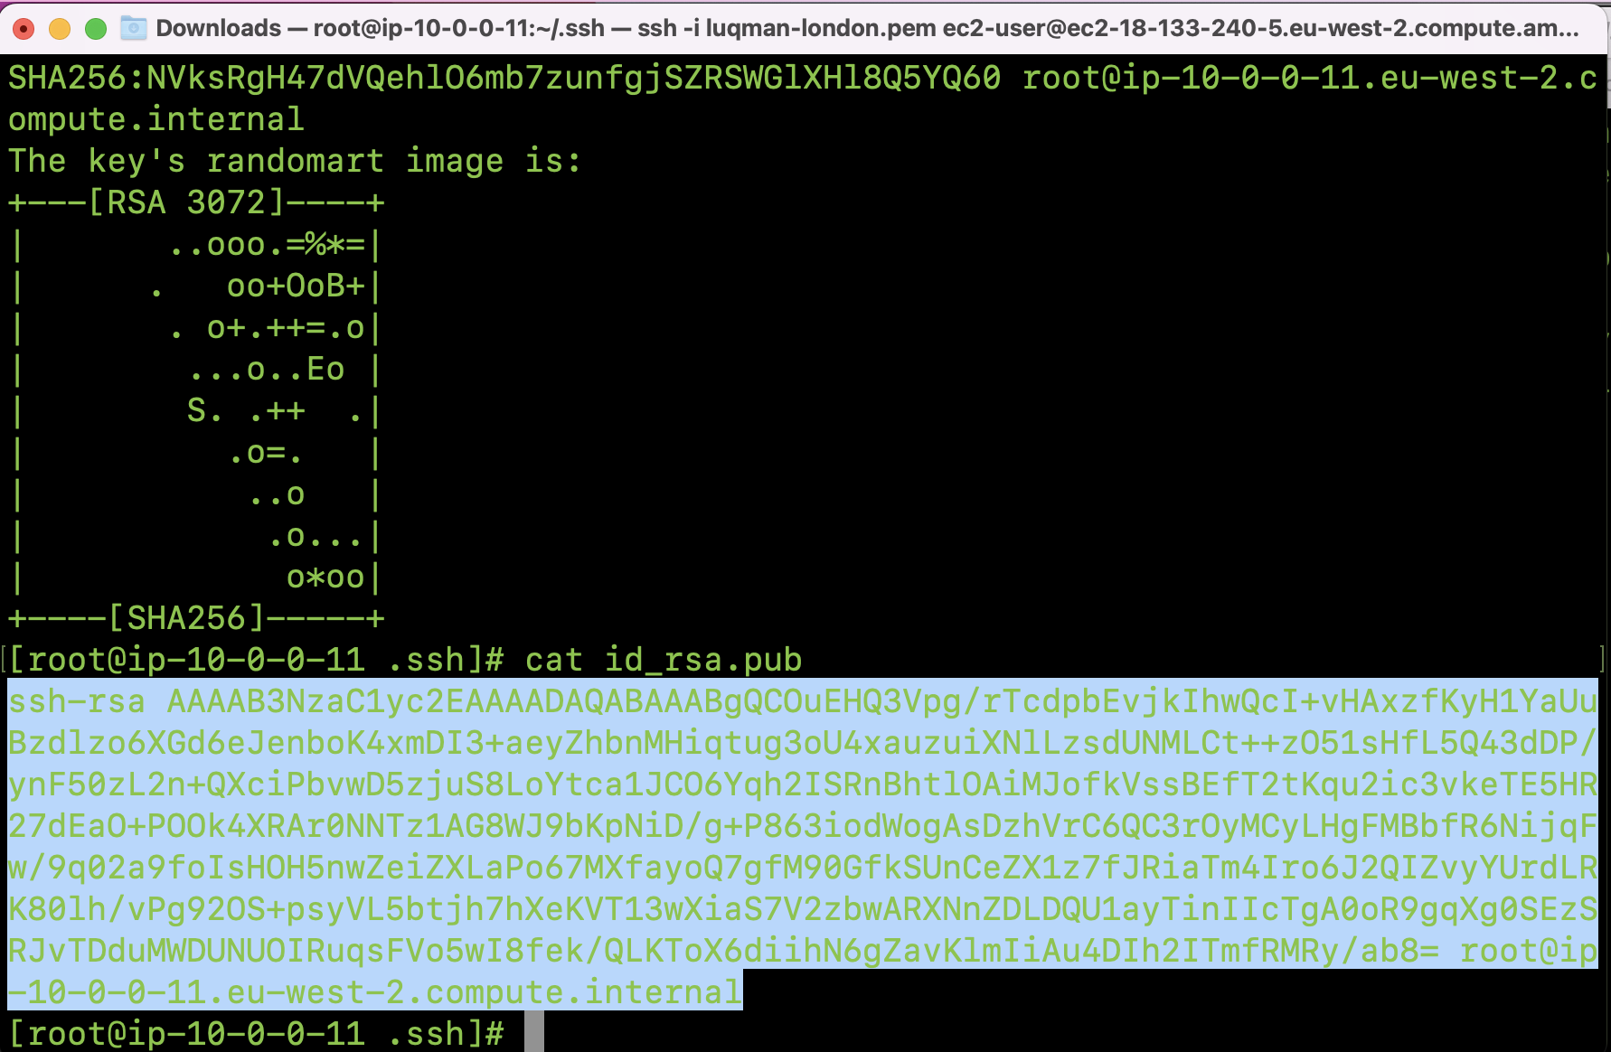

Paste the contents of id_rsa.pub into ~/.ssh/authorized_keys file on webserver-1 and webserver-2.

Run vi ~/.ssh/authorized_keys > click “i” > paste the contents of id_rsa.pub > click “ESC” + :wq!

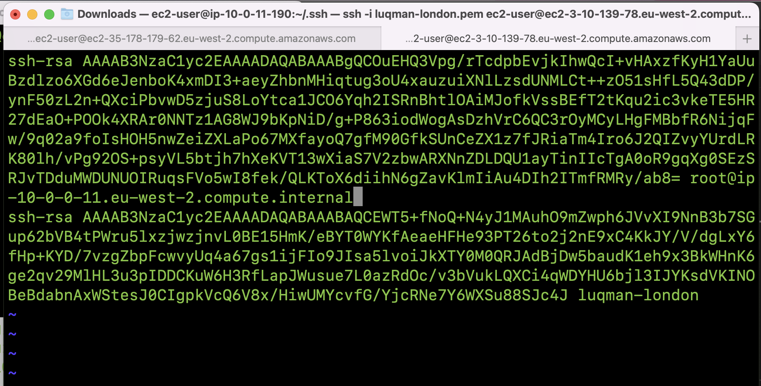

### What is ansible?

Ansible is an open-source automation tool that simplifies the management and orchestration of IT infrastructure. It is designed to automate tasks such as configuration management, application deployment, cloud provisioning, and intra-service orchestration. Ansible uses a declarative language to describe the desired state of the system and then performs the necessary actions to achieve that state.

Key features and concepts of Ansible include:

* **Agentless**: Ansible operates in an agentless manner, meaning it does not require any software or daemons to be installed on the managed nodes. It communicates with remote systems over SSH or Windows Remote Management (WinRM) to execute tasks, making it lightweight and easy to set up.
* **Playbooks**: Playbooks are Ansible's configuration management scripts written in YAML format. They define a set of tasks and the desired state of the system. Playbooks can be used to manage complex deployments, orchestrate multi-node workflows, and perform various administrative tasks.
* **Inventory**: The inventory file in Ansible lists the target systems or hosts that Ansible manages. It can be a simple text file or dynamically generated using external tools or cloud providers. Ansible uses this inventory to determine the hosts on which to execute tasks.
* **Modules**: Modules are the building blocks of Ansible. They are small, standalone scripts that perform specific actions on managed hosts. Ansible provides a vast library of modules that cover a wide range of tasks, including package management, file manipulation, service control, and more.
* **Roles**: Roles in Ansible provide a way to organize and reuse Playbooks and related files. A role encapsulates a specific functionality or application configuration and can be shared and reused across multiple projects.
* **Idempotent**: Ansible is idempotent, meaning it can be run multiple times without changing the end result. It checks the current state of the system against the desired state defined in the playbook and only applies the necessary changes to bring the system to the desired state.

Ansible is known for its simplicity, ease of use, and extensive community support. It is widely adopted by system administrators, DevOps engineers, and IT teams to automate infrastructure management and streamline application deployments.

### What is an ansible task?

In Ansible, a task is a fundamental unit of work that performs a specific action on a target system. Tasks are defined within Ansible playbooks and represent the individual steps or operations that Ansible carries out on managed hosts.

Tasks in Ansible playbooks are written using YAML syntax and follow a structured format. Each task consists of a task name, an optional set of variables or parameters, and a module invocation that specifies the action to be performed. Modules are Ansible's built-in scripts that encapsulate specific functionality.

Here is an example of a simple Ansible task that installs a package using the apt module:

| - name: Install nginx package  apt:  name: nginx  state: present |
| --- |

In this example:

* name is the name of the task, which provides a description of what the task does.
* apt is the module being invoked, indicating that the task uses the apt module for package management.
* name: nginx specifies the package name to be installed.
* state: present indicates that the desired state is for the package to be installed. If the package is already installed, Ansible will consider the task as successfully completed.

Tasks can include various actions such as installing or removing packages, copying files, running commands, restarting services, managing user accounts, and much more. Ansible provides a wide range of modules to perform these actions, and you can also create your own custom modules if needed.

Tasks are executed sequentially in the order they appear in the playbook, allowing you to define a sequence of actions to be performed on the target systems. Ansible takes care of executing the tasks on the appropriate hosts based on the defined inventory and performs the necessary operations to ensure the desired state of the system.

### What is an ansible module?

Ansible modules are responsible for executing specific tasks on target hosts. They can be written in any programming language, but most modules are typically written in Python. Each module is designed to handle a specific aspect of system management, such as managing packages, manipulating files, managing services, interacting with cloud providers, and more.

When Ansible runs a playbook, it connects to the target hosts and executes the relevant modules to perform the necessary tasks. Modules communicate with the target hosts over SSH by default, but other connection methods are also supported, such as local execution, WinRM for Windows hosts, and more.

Ansible comes with a wide range of built-in modules that cover common use cases. Additionally, the Ansible community constantly develops and contributes new modules, which are often shared and made available for others to use. These modules enable you to automate a broad range of operations across different systems and technologies, making Ansible a powerful tool for infrastructure automation and management.

### What is an ansible playbook?

An Ansible playbook is a high-level configuration file written in YAML format that defines a set of tasks, configurations, and policies to be applied to target systems. Playbooks provide a way to automate complex deployments, orchestrate multi-node workflows, and manage the configuration of IT infrastructure using Ansible.

Playbooks in Ansible are typically composed of one or more plays, where each play defines a set of tasks to be executed on a specific group of hosts. A play consists of a list of tasks, along with optional variables, conditions, and handlers.

Here's an example of a simple Ansible playbook:

| --- - name: Install and configure Nginx  hosts: web_servers  become: true   tasks:  - name: Install Nginx package  apt:  name: nginx  state: present   - name: Copy Nginx configuration file  copy:  src: nginx.conf  dest: /etc/nginx/nginx.conf  owner: root  group: root  mode: 0644   - name: Restart Nginx service  service:  name: nginx  state: restarted |
| --- |

In this example:

* name specifies the name of the playbook, providing a description of what the playbook does.
* hosts defines the target hosts or groups on which the playbook tasks will be executed. In this case, it targets the group of hosts named "web_servers."
* become: true indicates that the tasks should be executed with escalated privileges, typically using sudo or root access.
* tasks is a list of individual tasks to be performed in order.

Each task within the playbook performs a specific action using Ansible modules, such as installing packages, copying files, and managing services. The tasks are executed in the order they appear in the playbook, and Ansible ensures that the defined state is applied to the target hosts.

To execute an Ansible playbook, you can use the ansible-playbook command followed by the playbook filename:

| ansible-playbook playbook.yml |
| --- |

Ansible playbooks are powerful tools for automating infrastructure management, configuration, and deployment processes. They provide a structured and reusable way to define the desired state of systems and orchestrate complex tasks across multiple hosts.

### What is an ansible inventory file?

In Ansible, an inventory is a configuration file that defines the hosts or groups of hosts that Ansible can manage. It serves as a central source of information about the target systems on which Ansible performs automation tasks. The inventory file can be a simple text file or dynamically generated using external tools or cloud providers.

The Ansible inventory file allows you to organize your hosts into groups and assign variables to them. It provides a way to specify information such as hostnames, IP addresses, SSH connection details, and group membership. By default, Ansible looks for an inventory file located at /etc/ansible/hosts, but you can specify a different inventory file using the -i option when running Ansible commands.

Here's an example of a basic Ansible inventory file:

| [web_servers] web1.example.com web2.example.com  [database_servers] db1.example.com db2.example.com  [all:vars] ansible_user=ubuntu ansible_ssh_private_key_file=/path/to/private_key.pem |
| --- |

In this example:

* [web_servers] and [database_servers] are group names defined in square brackets. They categorize the hosts into different groups.
* The hostnames web1.example.com, web2.example.com, db1.example.com, and db2.example.com are listed under their respective group names.
* [all:vars] is a special group that applies variables to all hosts in the inventory.
* ansible_user is a variable that sets the SSH username to ubuntu for all hosts.
* ansible_ssh_private_key_file is a variable that specifies the path to the private key file used for SSH authentication.

Using the inventory, you can target specific hosts or groups in your Ansible playbooks and commands. For example, you can run a playbook against the web_servers group:

| ansible-playbook -i inventory.ini playbook.yml --limit web_servers |
| --- |

The inventory file provides flexibility and allows you to easily scale and manage large infrastructures with different host configurations. It enables you to define group-specific variables, control access to hosts, and organize hosts based on different criteria, facilitating effective management and automation with Ansible.

## Getting started with our ansible project

### Setting up ansible for your AWS instances

1. Create a folder on your Visual Studio Code called ansible.
2. Create your ansible inventory file in this ansible folder called “inventory.yml”. Create a group called [webservers] containing both the IP addresses of your web servers. You can even create sub-groups to further segmentise your web servers e.g. pri-webserver and sec-webserver.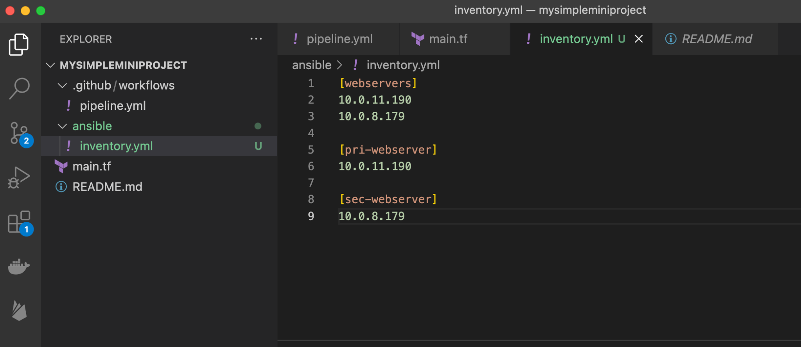
3. Create a simple playbook called install.yml.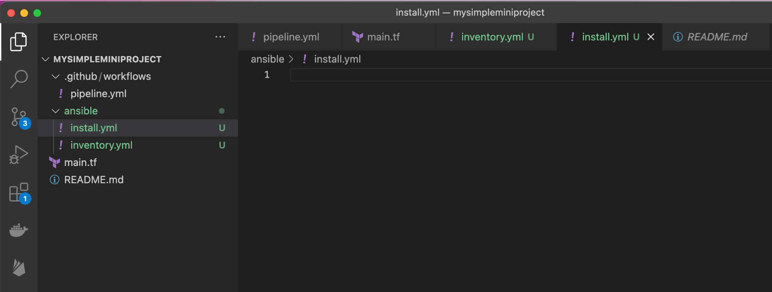
4. Copy the content below for the playbook:

---

- name: Install Apache web server

hosts: webservers

become: true

tasks:

- name: Install Apache package

yum:

name: httpd

state: present

- name: Start Apache service

service:

name: httpd

state: started

enabled: true

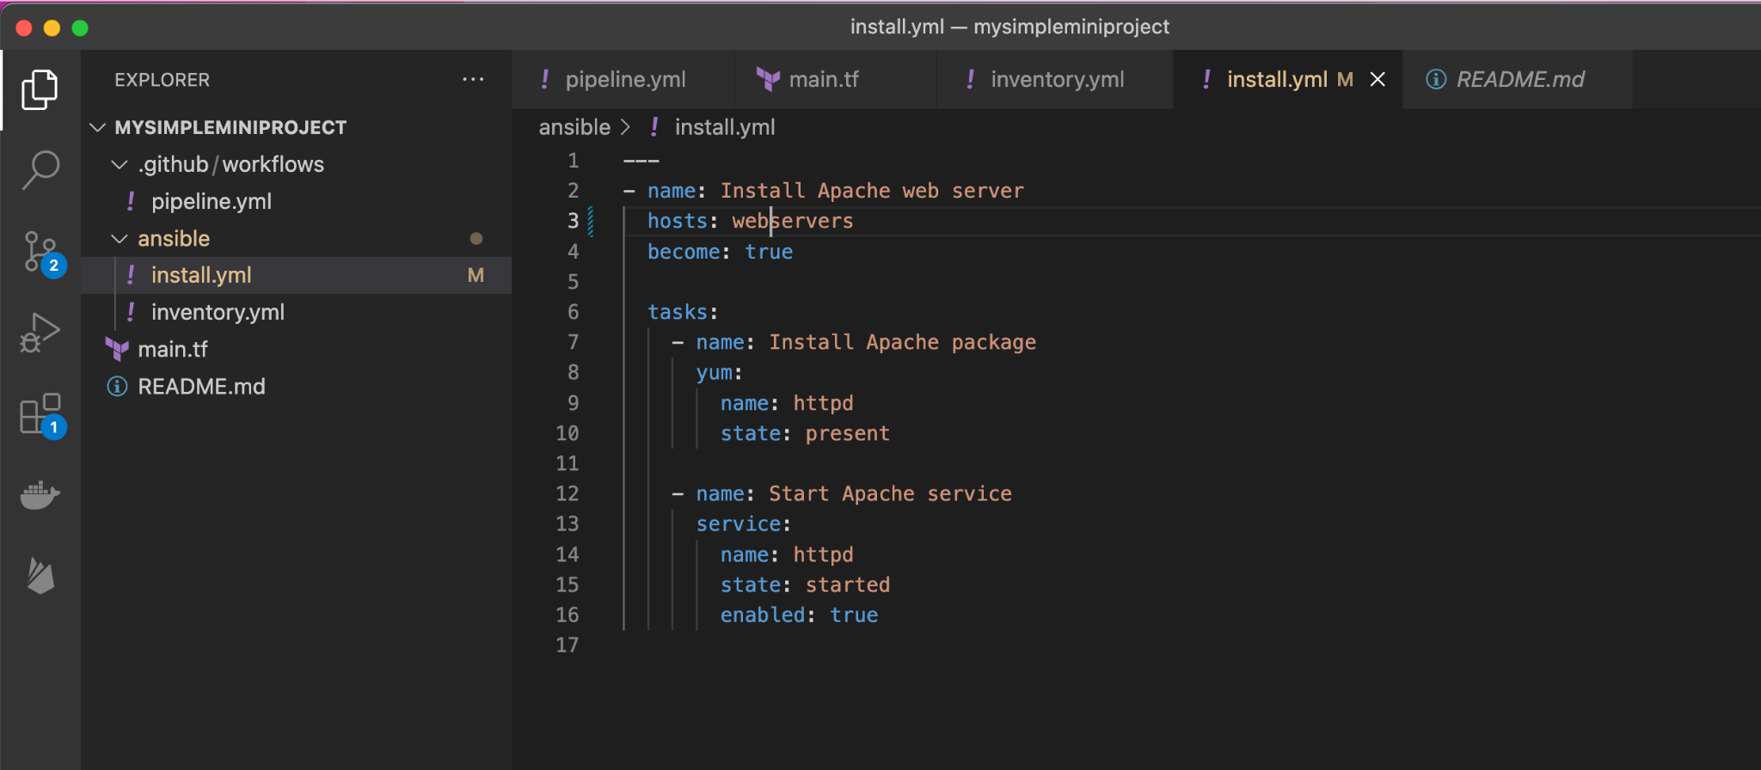

1. Push this ansible folder into your Github repository.
   1. Hint: git add . > git commit -m “<message>” > git push
2. On your ansibleserver, run git clone of the latest changes with the ansible folder.
3. Run the ansible command on ansibleserver to trigger an installation of apache web server on all web_servers:
   1. ansible-playbook -i inventory.yml install.yml

If you didn’t get this running, that’s OK! The permissions sometimes permits you from being able to run the ansible playbooks. Example:

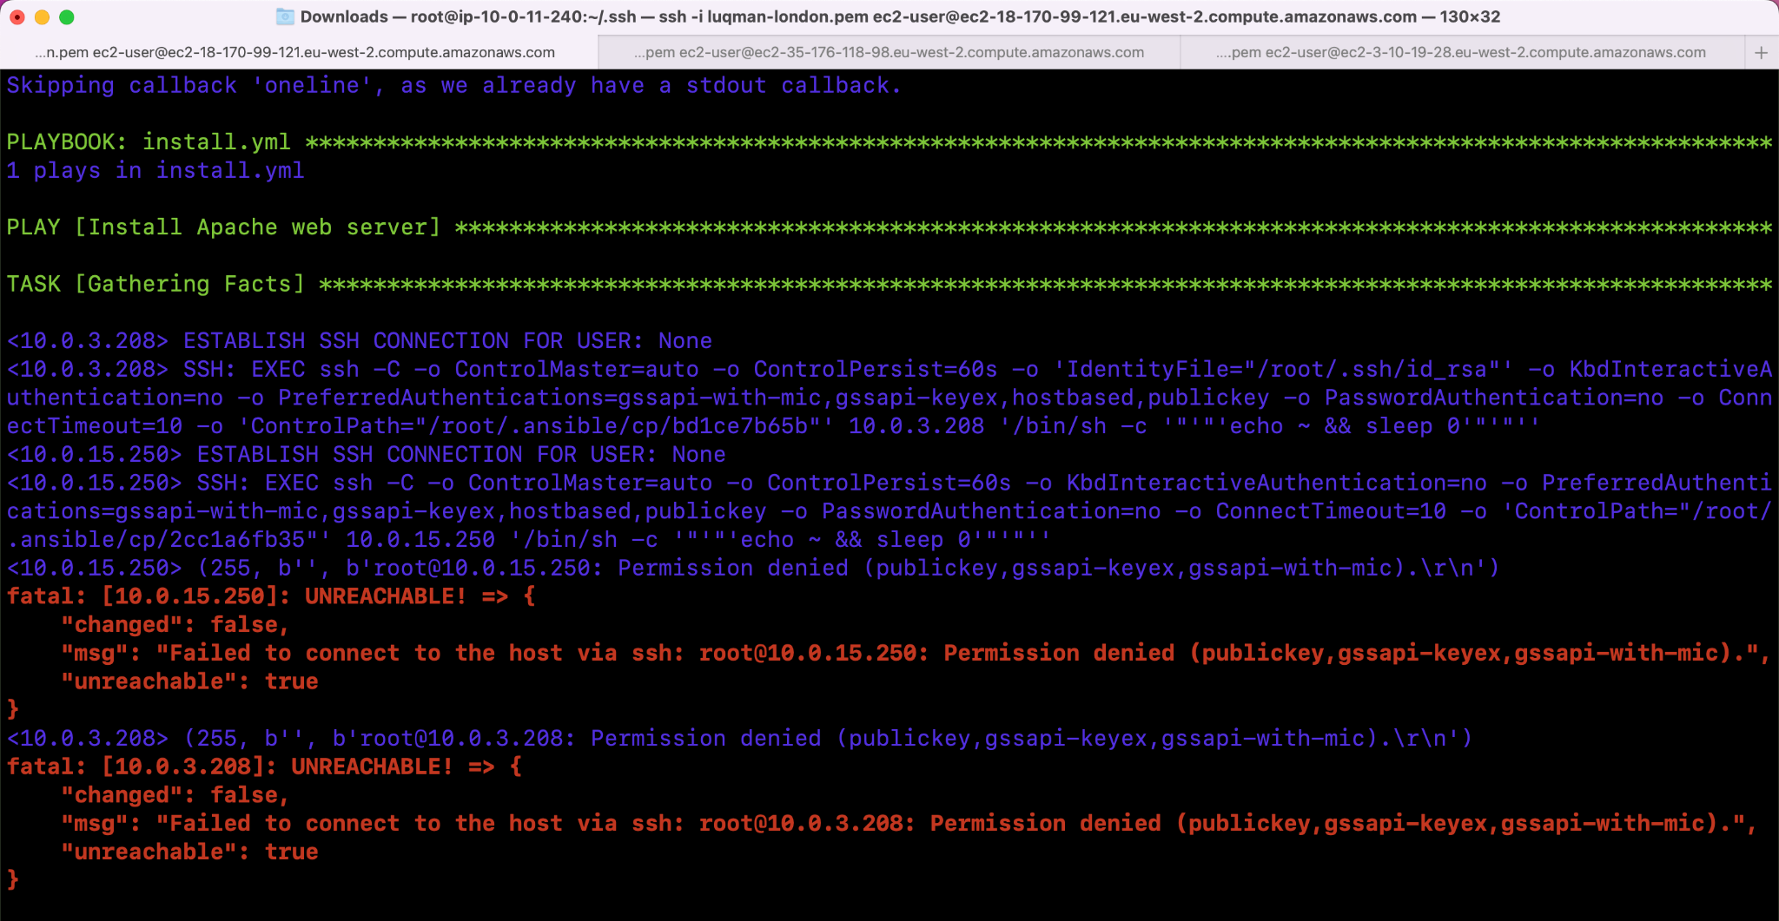

What you can do is to give this course a try: <https://nlbsg.udemy.com/course/learn-ansible/learn/>

It only takes a weekend or two to complete and has hands-on playgrounds set up correctly for you.